Center for Medical Humanities, Compassionate Care, and Bioethics.
Stony Brook University Health Sciences Center

33nd Annual History of Medicine Lecture Series
http://www.sunysb.edu/bioethics/historyofmedicine.shtml

"Parents Speak: Autism and the Ethics of Treatment."
Chloe Silverman, PhD
Penn State University

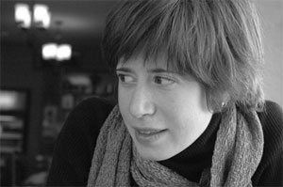

Biography: Chloe Silverman is Assistant Professor of Science & Technology Studies and Gender Studies at Penn State University, State College, PA. Dr. Silverman received a Ph.D. in History and Sociology of Science from the University of Pennsylvania (2004) and was a Mellon postdoctoral fellow at Cornell University in the Department of Science & Technology Studies (2004-2006). Her manuscript, Autism, Love and Labor, to be published this year, describes the role of parent advocacy groups, teachers, and neuroscientists in the shaping of the diagnostic and clinical entity of autism spectrum disorders in a series of historical and physical locations, including the Sonia Shankman Orthogenic School at the University of Chicago, the early years of the National Society for Autistic Children, and contemporary parent advocacy groups devoted to promoting “biomedical interventions” for autism.

Thursday, February 18, 2010
Health Sciences Center Lecture Hall 1, level 2
5:30 p.m.

