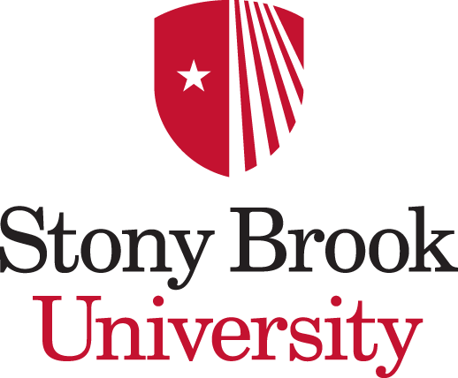
Biochemistry and Structural Biology Graduate Program

OFFICIAL RECORD of ANNUAL THESIS COMMITTEE MEETING

Students should download this form from http://www.stonybrook.edu/bsb/forms/index.html prior to the committee meeting and send to the committee Chair. This will give the Chair an MS Word document that can be edited on their computer and submitted by email. Add as much text to answer the questions as needed. i.e. this does not need to be kept to 1 page.

Name of Student: Year of Matriculation:

Name of Chair: Name of Advisor: Date of Meeting:

First Meeting Interim Meeting Last Meeting

RESEARCH PROGRESS: (Completed by Committee Chair)

Written summary of progress (provided by student) sent to committee 1 week prior to meeting (please indicate): YES NO

Overall Outcome (Indicate one): Student is on-track A meeting is needed before the next annual meeting

- Discuss the student’s progress since the last meeting. If the student is on-track, describe why. If the student has encountered problems, describe the plan to resolve them.

- List goals to achieve by the next scheduled meeting:

- Describe the plan for a 1st author publication for students at the end of their 3rd year (or beyond)?

- Next meeting recommended: 6 Months 9 Months 12 Months
(Students in year 6 and beyond must meet with their committee a minimum of twice per year.)

- The student has met the 1st author publication requirement. (This requirement has to be met before the defense date is scheduled).

- The student has been given permission to schedule their defense date.

CAREER GOALS:

Have steps been taken with regard to career preparation? Has the student mapped out career goals in an Individual Development Plan (IDP)? Students are not required to discuss their IDP, however, the committee should discuss the issues surrounding graduation in a timely fashion and moving ahead with their careers.

NAMES of COMMITTEE MEMBERS PRESENT:

The chairperson is responsible for a summary of the proceeding of these meetings and its submission to the Program office.

Please email to Amy.Saas@stonybrook.edu

