FAQ for Entering Publications into Digital Measures
It is very important for AACSB reporting requirements that intellectual contribution publications get entered correctly. All publications must contain the following to pull into the AACSB reports:
- Contribution type
- AACSB classification
- current status
- was this peer-reviewed/refereed?
- is this publicly available?
- date that includes month and year

- Entering a Journal Article
Select the Intellectual Contributions screen and then Add New Item.

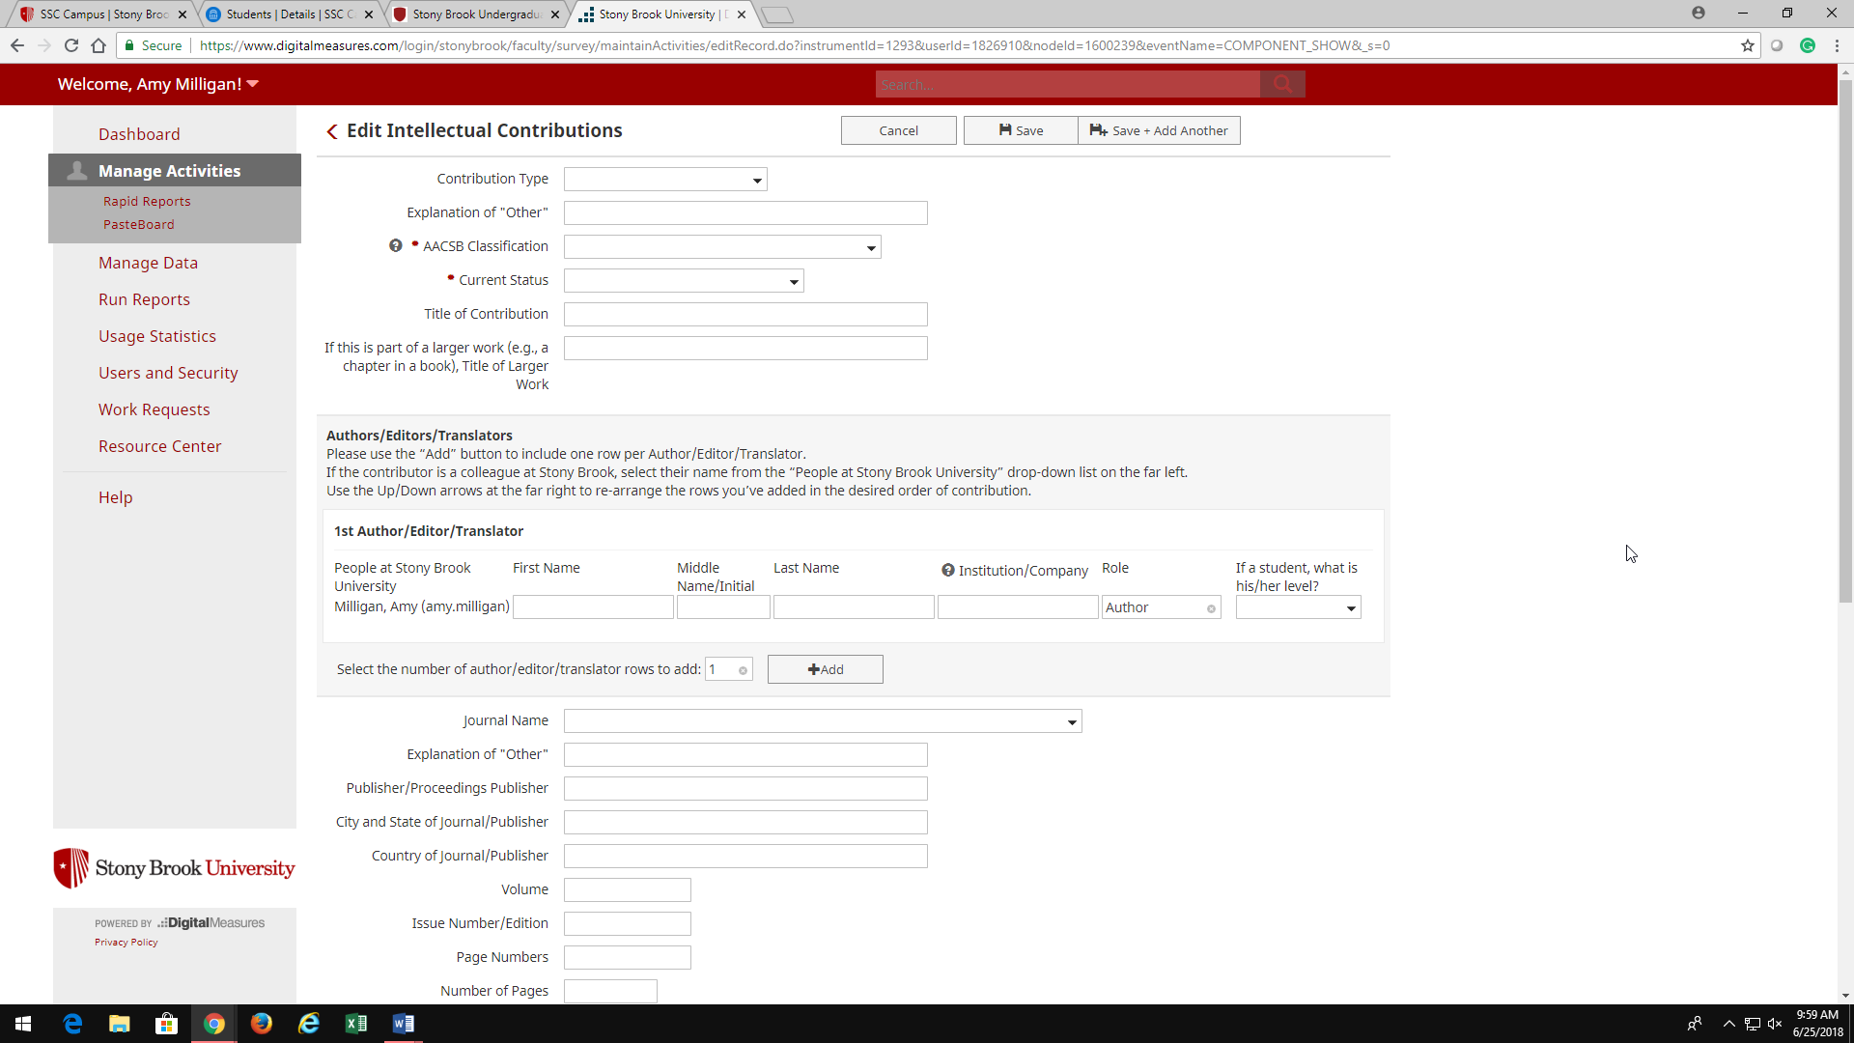

- Be sure to complete the AACSB Classification, if you are unsure what to select, click on the question mark for the definitions. Then select the current status. Please update this as you move through the review process.

- The Title of Contribution should be entered correctly.

- Do not use “If this is part of a larger work (e.g., a chapter in a book), Title of Larger Work” for journal articles.

- Add your collaborators, if you wish to do so.

- Journal Name: VERY IMPORTANT - please review the drop-down list before entering in “other”. I am finding many “other” that are on the drop-down. This causes issues with reporting, so please take the time to do this correctly.

- Please only use “other” for a journal name that is not included in the drop-down. When entering a journal name be sure to capitalize and enter correctly, no abbreviations.

- Do not use “other” to enter working papers.

- Do not use “other” to enter book titles.

- Entering a Book Chapter
Enter the chapter in Title of Contribution and the name of the book below it If this is part of a larger work, Title of Larger Work.

- Entering a Proceeding
A publication in a proceeding should be entered in the same way as a journal article. The word “proceeding” should be in the title, for instance, “Proceedings of the Academy Management.” Volume number and pages should be indicated.

Note that a proceeding is not the same as a conference presentation. Some academic societies select a small number of presentation from their annual conference for publication in a volume of proceedings. The society may allow you to submit a variation of the paper to a journal, but not the same proceedings paper, which stands on its own as a publication. As such, we count it as a peer reviewed journal article for AACSB purposes.

