AP Approval
User Guide

AP Approval User Guide – Approving or Rejecting Transactions
Last Updated: 7/28/2021

Important Note

As the Avid system is managing sensitive financial information – there is security build in to protect these transactions. When an SBF user is logged on, if there are 10 minutes of inactivity, the system will automatically “time out” and log the user off the system. Please utilize the “Update” and “Update Detail Line” buttons to save your work.

Introduction: This document is an Avid site guide designed for SBF approvers. Here are the topics covered:

Logging on / Home Screen / Status of your AP Invoices………………………………………………………….1-3
Approving a Transaction.………………………………………………………………………………………………………..4-7
Rejecting a Transaction………………………………………………………………………………………………………… 7-8
Search Functions……………………………………………………………………………………………………………………. 9

Approving a Transaction:

KEY NOTE: Please make sure to read the language on the top of the websites log-in page in the blue highlighted box. This is your attestation that this transaction meets the donor’s intentions and complies with the Foundation’s policies and procedures

Log in to the SBF Avid site. https://sbf.arietttouch.net/

STEP ONE - type in your User Name and Password. Your user name will match how your name is spelled for your SBU e-mail. . On your first login, all users will have the same password which is Password123 (the “P” is in caps). Click on “Sign In” to go to the Home Screen

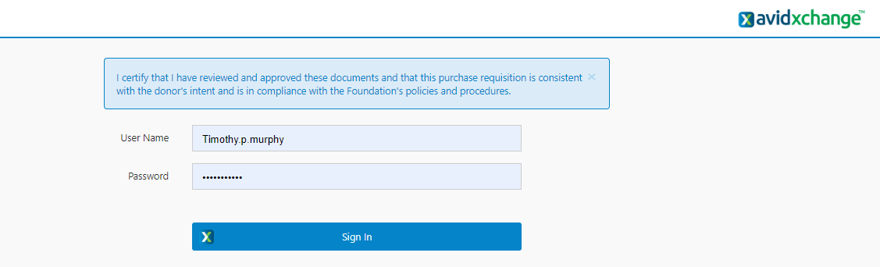

Once you have accessed the Avid system for the first time, you need to create your own unique password. Please follow the steps below:
- Click on the hamburger sidebar menu in the top left corner
- Click on “User Options”
- In the User Password section, type in the New Password in both fields
- Click Update
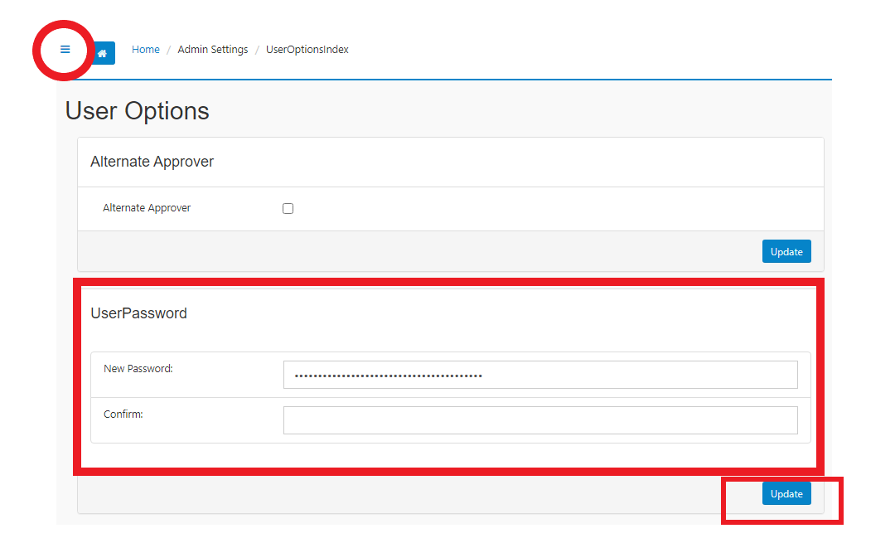

Password Requirements:
- At least 7 characters
- At least one capital letter
- At least one lowercase letter
- At least one number or special character
- Special characters allowed: !, #, $
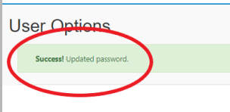

You have now successfully created your own unique password. Click on the “Home” button on the top of the page to return to the Home Screen
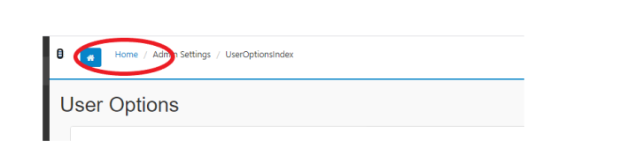

Home Screen – This gives you a status of your AP invoices

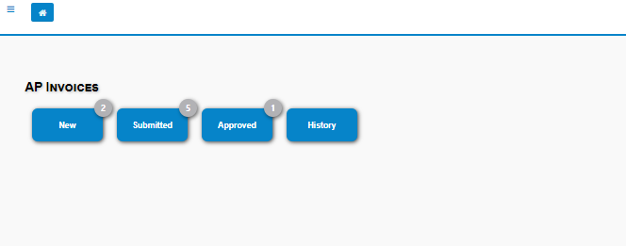
- NOTE: The number in the upper-right corner is a count of your existing Invoices.

STEP TWO - Click on Submitted queue to view the AP invoices that are waiting for your approval. NOTE - The grey number on the top is the number of submitted transactions

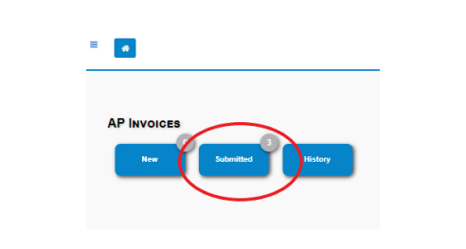

STEP THREE
- Click the transaction number in the APNumber column to view transaction details
- Click on View to be taken to the AP Document view – this will show the transaction on the left side and the uploaded document(s) on the right side. Note - You will not be able to add any comments in this view
- Clicking the in the transactions row will allow you to download and view any uploaded attachments before viewing details

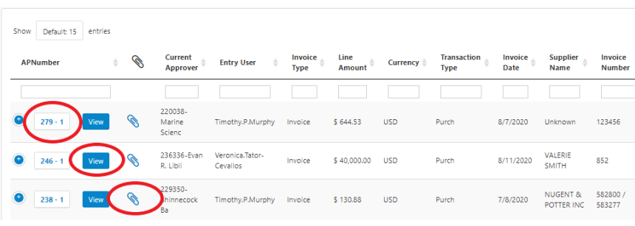

- You can add comments starting with the date (i.e. 3.8.21) to the transaction details by typing in the empty text field near the top of the screen and clicking Add Comment.
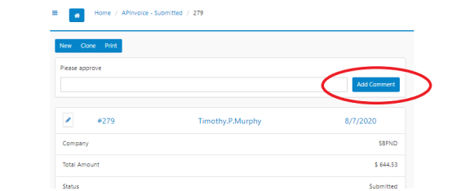

- You can make changes to the transaction by clicking the icon in the section you would like to edit.
  - If the is not visible than you do not have edit rights. Contact the SBF Office Administrator if you need to have your User Settings adjusted.
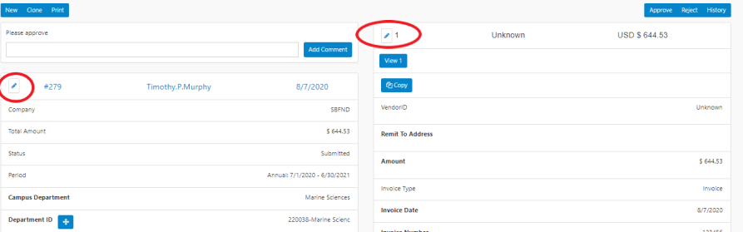

To view a transactions audit trail, click History in the upper-right hand corner of the screen. Click Back to return to the previous page
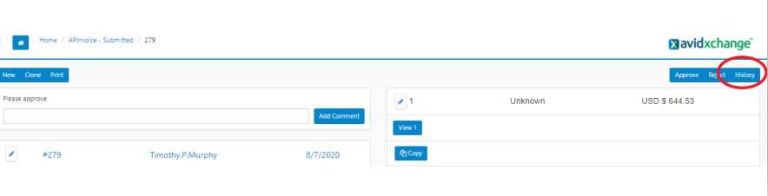

STEP FOUR When you are ready, click Approve in the upper-right hand corner of the screen.

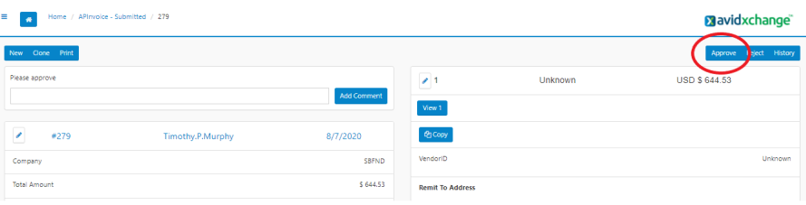

When successful, you will receive a notification banner that the transaction has been submitted to the next approver(s), or sent to the SBF-Posters if fully approved.

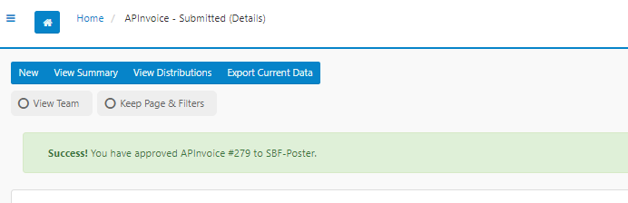

Rejecting a Transaction:

If a transaction should not be approved, it must be rejected back to the entry user for review.

STEP ONE Add a comment starting with the date (i.e. 3.8.21) to the transaction explaining why it is not approved. Type your comment into the empty text field near the top and click Add Comment

Key Note – To reject a transaction – you must add a comment or the system will send you an error message like the one below

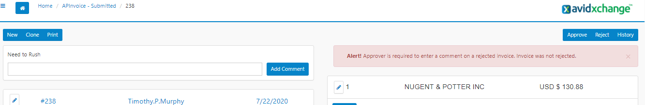

STEP TWO Once the comment has been added, click the Reject button in the upper-right hand corner of the screen.
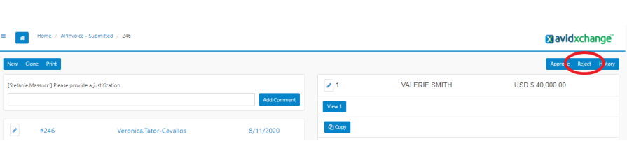

When successful, you will receive a notification banner that the transaction has been rejected.
This will send the transaction back to the entry user so they can make the proper adjustments before resubmitting the request.

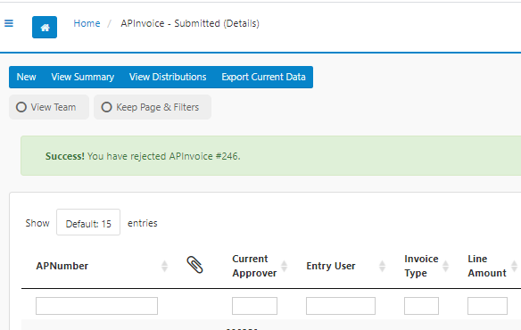

Please Note: Approval notifications for the transaction will now say “Resubmitted”, indicating to Approvers that it is a resubmitted transaction they may have already viewed and approved.

Search Functions
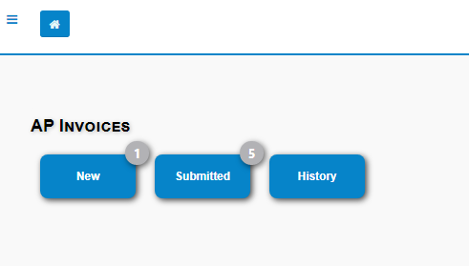

- If the transaction has not been posted, click into “New” que, then click the “View Team” button in top left, then filter/resort on any column
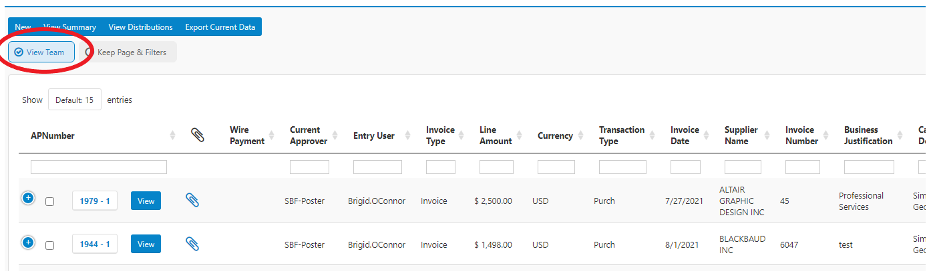

- If the transaction has been posted, click into “History”, then click the “View Team” button in top left and filter/sort as needed. Key fields include “Voucher Number” and “Status”

