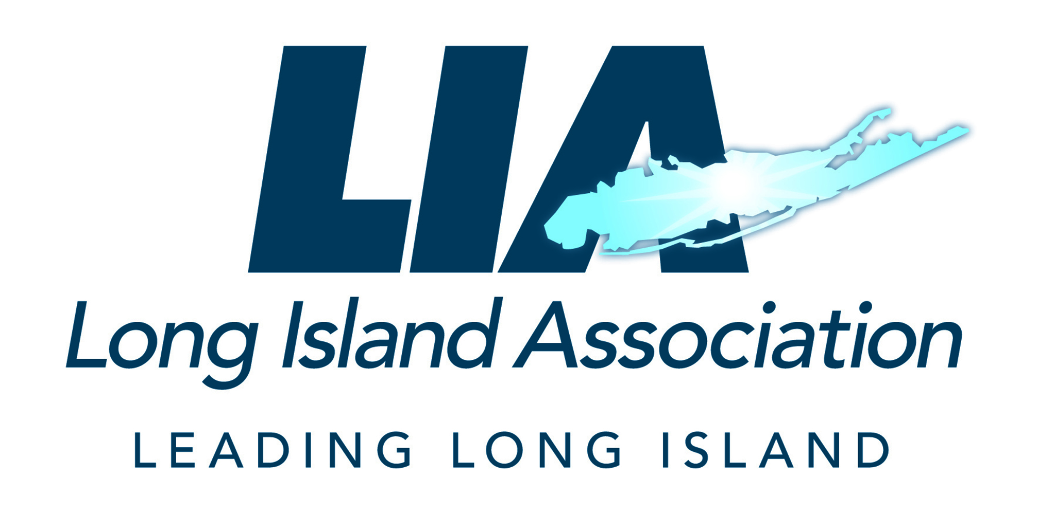 | Kevin S. Law  President & Chief Executive Officer  Long Island Association

February 8, 2021

The Honorable

Dear :
The Long Island Association supports Governor Cuomo’s language in the Executive Budget providing authority for flexible tuition for SUNY’s four University Centers which includes Stony Brook University.
Stony Brook University is a $7.6 billion economic engine on Long Island and one of the region’s largest employers that serves a broader purpose through research, innovation, clinical care and education. Premier education, groundbreaking research, exceptional clinical care and meaningful community engagement all require substantial funding. Yet Stony Brook has not seen any operational increases for nearly 10 years, has had to cover additional operational costs due to contractual salary increases and is now facing the prospect of cuts to staff and programs due to the COVID-19 pandemic. When searching for faculty and building programs, Stony Brook goes up against the best universities in the country and needs the resources to compete so that they can continue on their trajectory of research and academic excellence.
Furthermore, we are aware that Stony Brook is taking an active role in working with New York State to combat the pandemic while helping to solve many of state’s most pressing goals in areas such as climate change, health disparities, artificial intelligence and quantum computing. Their expertise has been instrumental in the development and implementation of regional COVID-19 testing and vaccination strategies. Moreover, Stony Brook has produced personal protective equipment and other products used in testing and treating COVID-19, and their infectious disease and public health experts has advised government officials throughout the pandemic.
We know New York State faces an unprecedented budget challenge that will not allow for increased operational support to Stony Brook. The authority for flexible tuition will allow for greater access to excellence for all students—even students with financial need. This authorization will also provide Stony Brook with the resources to ensure access to their most financially vulnerable students and will hold those with the greatest need harmless.

Therefore, I am respectfully requesting that you support the Governor’s Executive budget to give Stony Brook University and the University Centers flexibility, allowing them the financial relief needed at this time of crisis so that they can continue to serve Long Island and the state through their innovative research, clinical care, education and engagement with their local communities.

Sincerely,
Kevin S. Law
President & CEO
Long Island Association

