PHY 133 L69 Lab Syllabus
Welcome to PHY 133 Lab! This lab class is a so-called “online lab”. It is perhaps better described by the phase “at home” laboratory. You will purchase the ioLab device as part of a lab kit and use these items to perform all your experiments. Following each experiment you will submit a lab report through blackboard and take a quiz testing your understanding of the material for the lab.

ioLab Device
Macmillan publishing distributes the so-called ioLab device. Each student should purchase their own ioLab from Macmillan. The web page is somewhat confusing. You will need the KIT (not merely the device). The KIT is known as the “package” and the web site looks as follows:
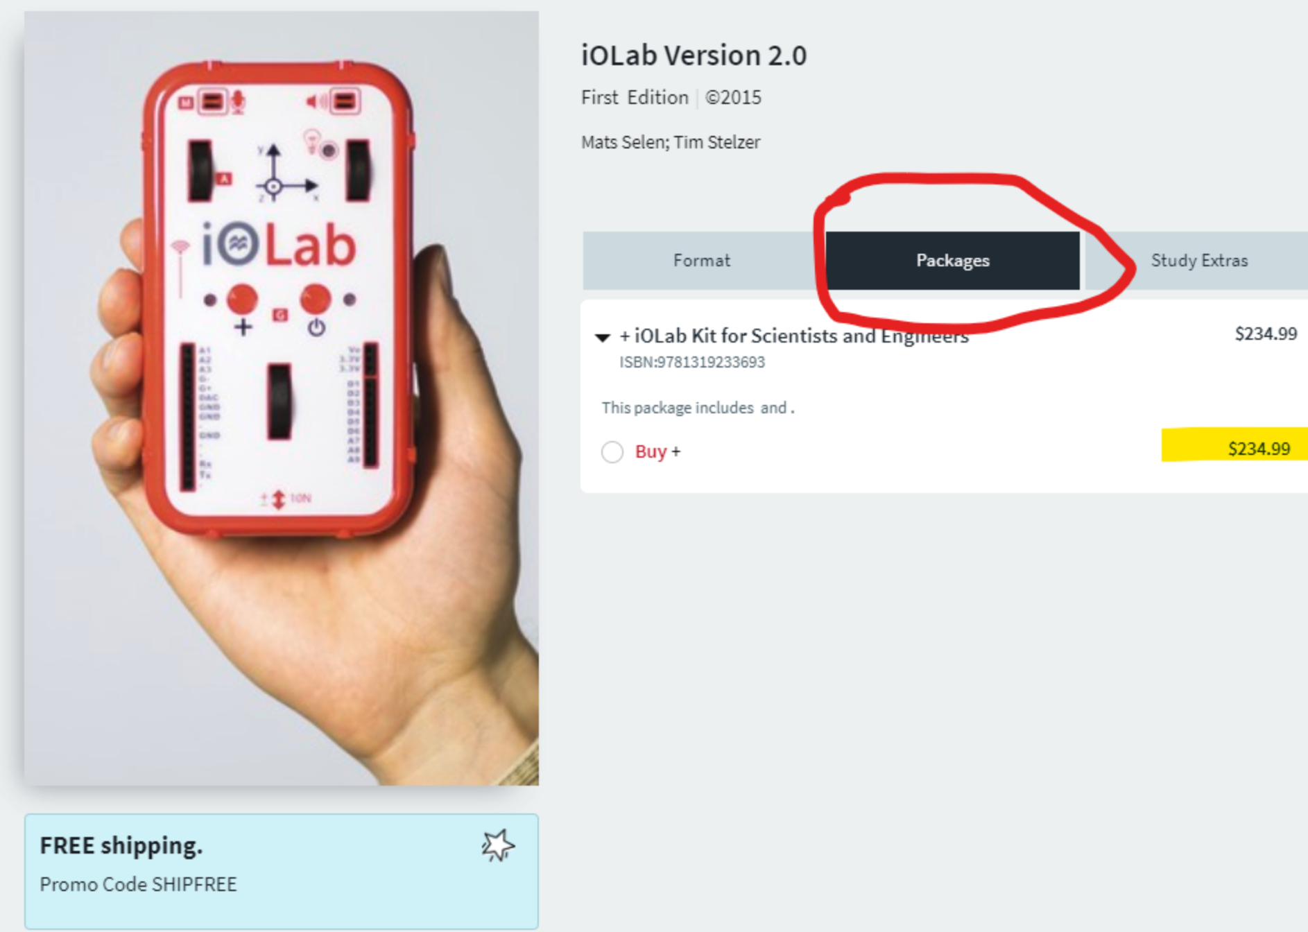
This device will serve all your needs for PHY133 and PHY133.
After you receive the device, follow ALL the instructions found in the “Downloads” section of the blackboard web site in order to get the device and the lab writeups properly installed. Be particularly careful about the folder into which you installed the lab manuals. If correctly done, you will be able to open the lab manuals inside the ioLab app. If incorrectly done, you will open them in a web browser and equations will not be shown.

Lab Reports
The expectations for lab report content are discussed in detail on the blackboard web site. A guiding principle of the lab writeup is to write a standalone document. You can be brief, but your document should be sufficient for someone else to:
- Understand what you wanted to prove
- Understand how what you decided to measure
- See what you did measure
- See what you calculated
- REPRODUCE YOUR CALCULATIONS (!!!)
- Understand what you concluded.
Your lab reports will be handed in through the “Smart Assign” system. This system compares your report to all other students in your class, all other students from prior classes, and the internet. TAs will investigate cases of high plagiarism score. Both the student who copied and the student who was copied-from will receive zeroes on the lab report.

Lab Quizzes
In addition to the lab report, you must complete a lab quiz. Both are due on the same day, but it is suggested to do the lab quiz after the lab report so that you can benefit from having learned something by performing the lab.

Grade Determination
Your lowest quiz and lowest lab score will be dropped. Your course score will be a weighted average of the reports (80%) and the quizzes (20%). Your grade will be set on the following scale:
 | A | A- | B+ | B | B- | C+ | C | C- | D+ | D | F
Percentage | > 90 | 85-89 | 80-84 | 75-79 | 70-74 | 65-69 | 60-64 | 55-59 | 50-54 | 45-49 | < 45

Labs
The list of labs includes:
- Orientation (not for credit)
- Linear Kinematics
- Force and Acceleration
- Force of Friction
- Circular Motion
- Hooke’s Law and Springs
- Momentum & Energy
- Simple Harmonic Motion
- Simple Pendulum
- Standing Waves
- Speed of Sound

Getting Help
Each student is assigned “their TA”. These assignments will be announced via the class blackboard page. When requesting help, please do the following:
- Write to your TA
- Copy to PHY134.LeadTA@gmail.com
- When appropriate attach a photo of your setup.

AFTER you have completed the lab. They are meant to test you on what you did and what you
learned during the labs. The quizzes will be posted on Blackboard under Assignments/Quizzes.
Quizzes will be due on the SAME DAY as the associated lab report. You must complete the lab
quizzes in one sitting! Therefore, please make sure you have enough time to complete the full

